PROJECT STATEMENT CERTIFICATION- PI/FACULTY

- Access UNT Denton ’ Employee Compesnation Complaince (ECC) System for your certification through the email you received or by going directly to the ECC System environment at https://untsystem.huronecc.com/ecc/.

- Log into the application through SSO and using your UNT Denton username/password.
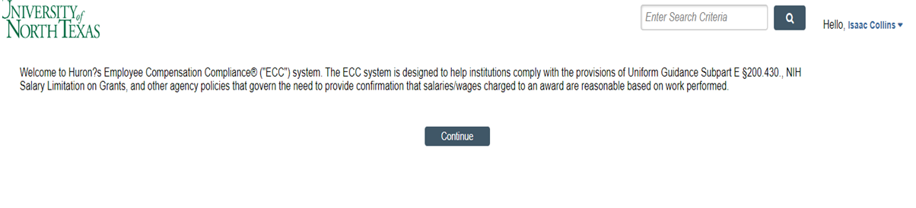

- You are viewing the Home Page. The Home Page will display your Worklist. The Worklist displays two sections:
  - Project Statements
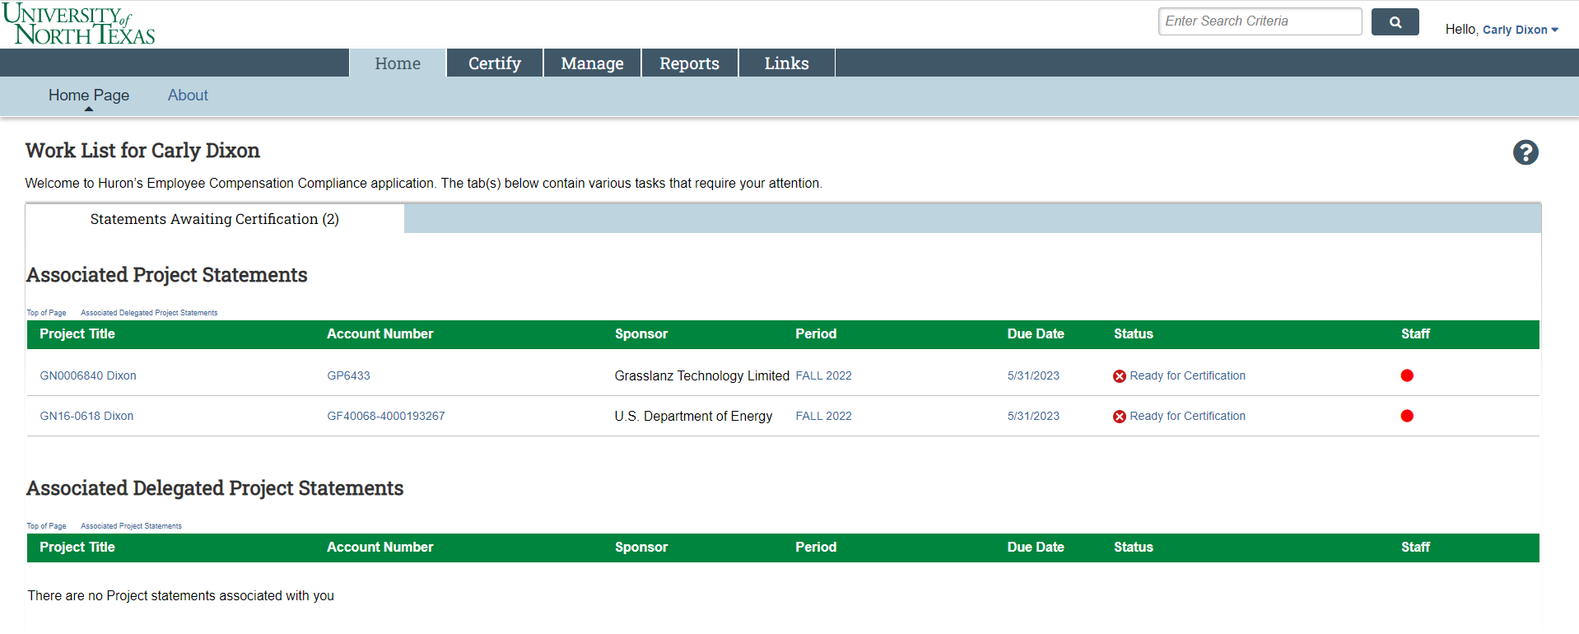
  - Associated Project Statements

- Per UNT Denton ’ policy, you are required to certify all Project Statements you are the responsible PI for.

- To access your Project Statements for certification, click on any link associated to the  line under Project Statements.
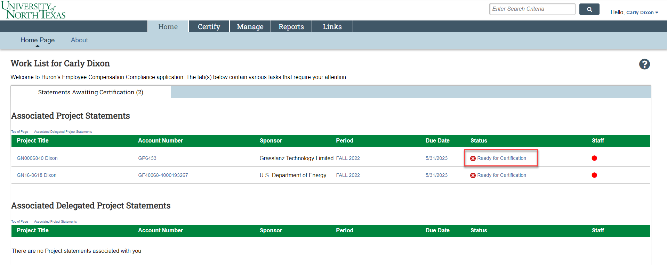

- The Project Statement you selected on the Home Page will be displayed.

- To view all Project statements at one time, click the Select All icon
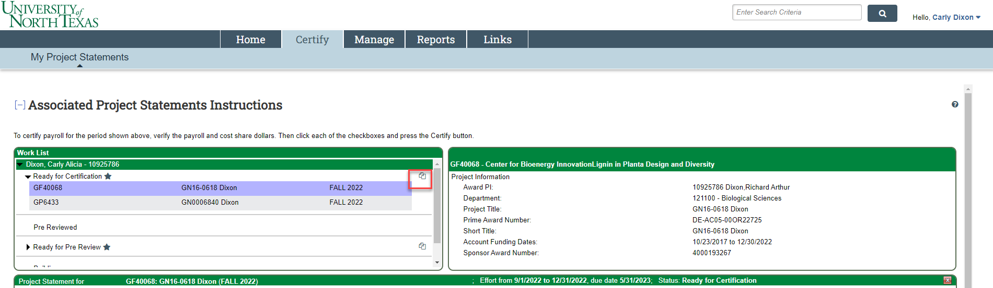

- The Project Statement lists all UNT Denton Faculty and non-faculty employees that were paid from the Projects for which you are a PI.
  - The statement displays the individual’s total payroll, and any applicable salary-over-the-cap (SOC) or cost share dollars, for the reporting period.
  - To view an employee’s 100% payroll distribution, click the icon in the Details column.
  - Review the Project Statement(s), review all accounts, ensure that all non-faculty employees are listed and that the payroll dollars are accurate.
    - Your department administrator has already reviewed your Project Statement and it should be accurate. If you have questions about your Project Statement, you can click the ‘Get Help’ button to email your administrator about any issues you may be having.
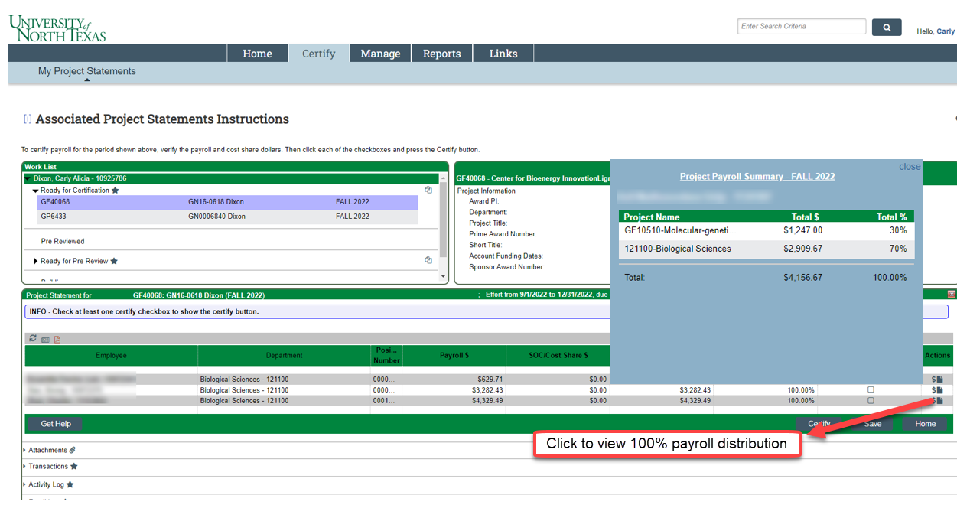

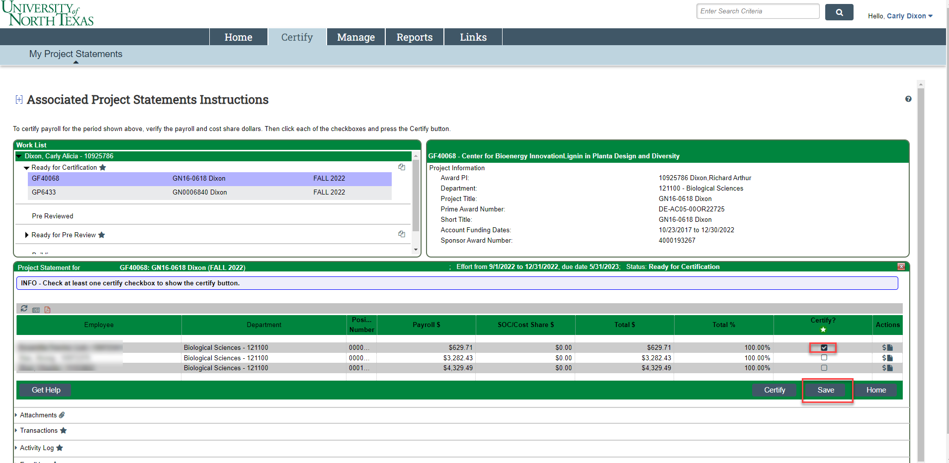
- If you wish to save your progress reviewing each line of the statement, select each line you wish to save and click the ‘Save’ button to return to complete the certification processs at a later time.

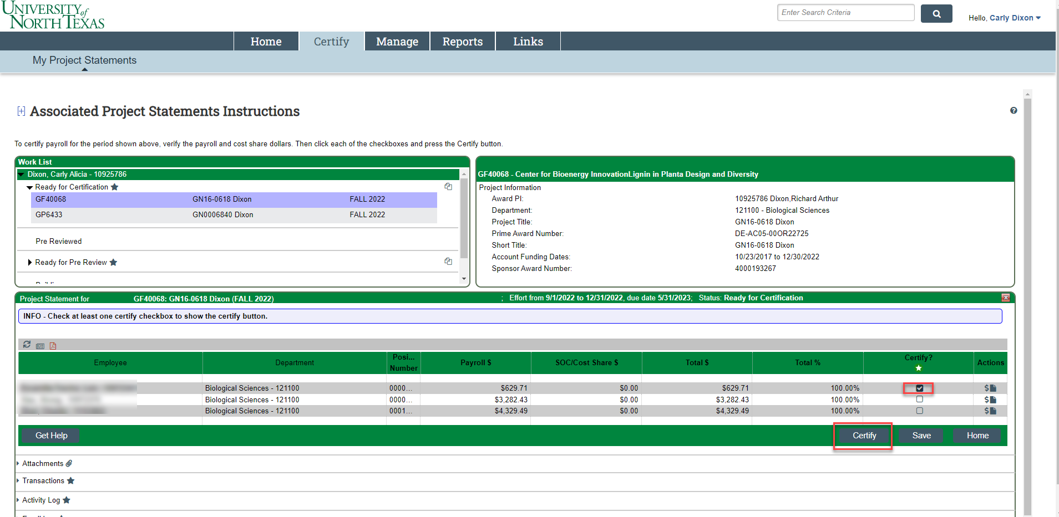
- If you wish to partially certify certain lines of the statements that you have reviewed, select only lines you wish to certify and click the ‘Certify’ button to return to complete the entire certification process at a later time. The statement will remain on your Worklist until you have certified every line of the statement.

- To certify the entire Project Statement:
  - Select the individual check boxes under the ‘Certify’ column or select the green star , which is a ‘check all’.
  - Select the ‘Certify’ button which has now appeared.
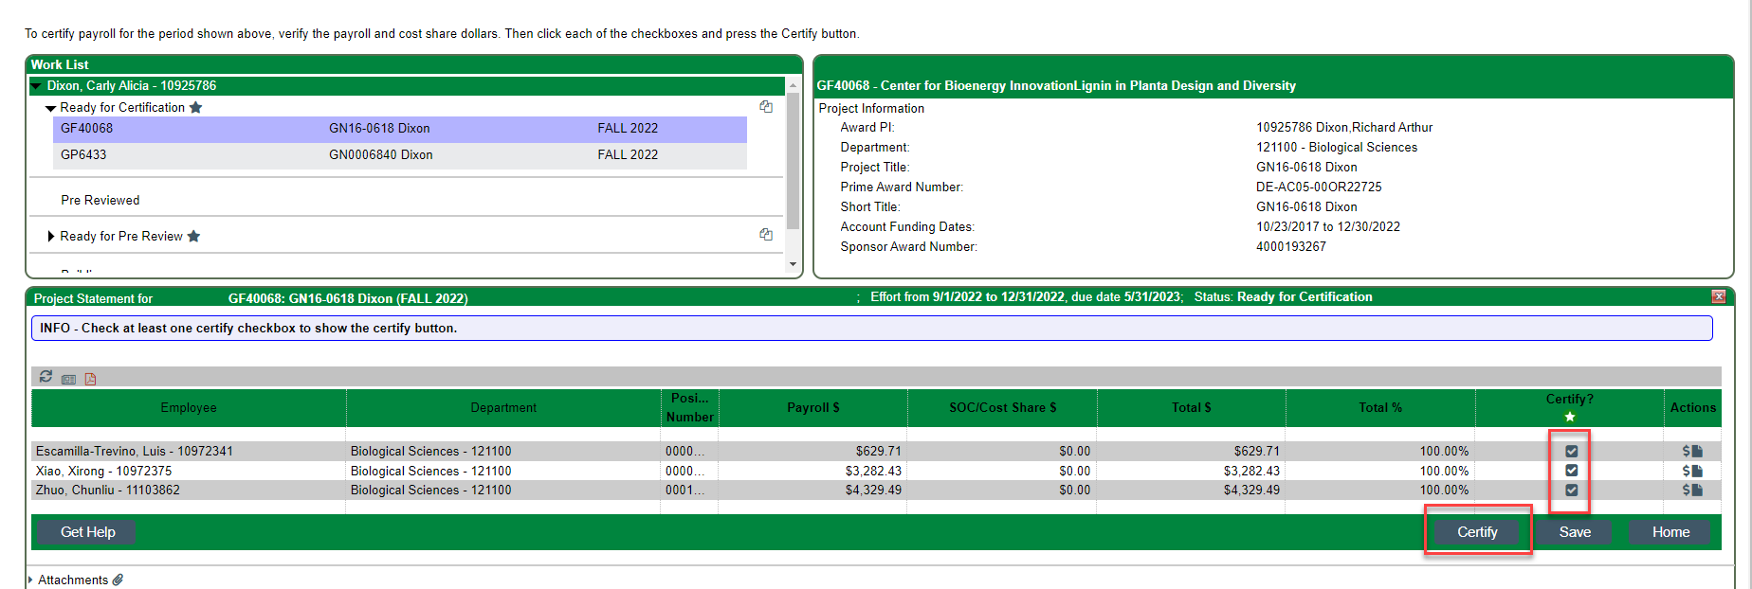

- Review the attestation statement and select ‘I Agree’ to complete the certification.
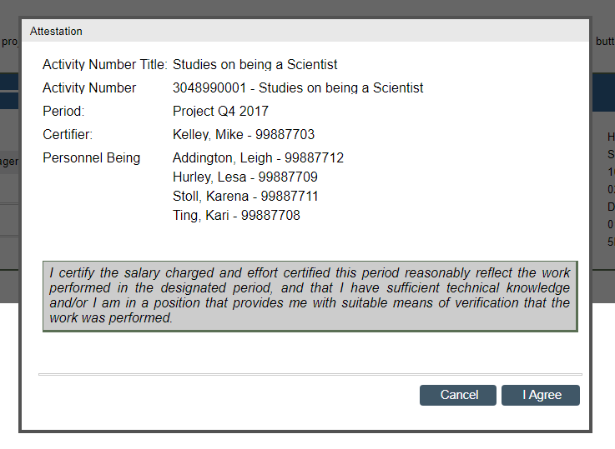

- Your Project Statement is complete and has been removed from your worklist.
  - You will need to do this for each one of your Project Statements.

